**R.V. COLLEGE OF ENGINEERING, BENGALURU- 560059**

**(Autonomous Institution Affiliated to VTU, Belagavi)**



**TITLE: OBSERVE PROCESS FILE TABLE ENTRIES AND FILE OBJECTS ACROSS PARENT AND CHILD PROCESSES**

**Experiential Learning Report**

**Submitted by:**

**Anushka Agarwal (1RV20CS026), Atharv Gupta(1RV20CS034),**

**Gadaputi Ashritha(1RV20CS052)**

**Department of Computer Science and Engineering**

**Section: CSE-A**

**Submitted to:**

**Professor: Ms. Jyothi Shetty**

**PARENT AND CHILD PROCESSES**

Parent process is the one that creates the child process, using a system call fork().

A child process uses the same program counter(pc), same CPU registers, same open files as that of the parent process.

exec() system call is used after fork() by one of the processes to replace the process’s memory space with a new program.

**PROCESS FILE TABLE**

A process control block (PCB) contains information about the process, i.e. registers, quantum, priority, etc.

The process control block contains a file descriptor table that gives the mapping between the descriptor the process uses to refer to a file connection and the data structure inside the kernel that represents the actual file connection.

**FILE DESCRIPTOR**

A file descriptor is a number that uniquely identifies an open [file](https://www.computerhope.com/jargon/f/file.htm) in a computer's [operating system](https://www.computerhope.com/jargon/o/os.htm). It describes a data resource, and how that resource may be accessed. At least one file descriptor exists for every open file on the system.

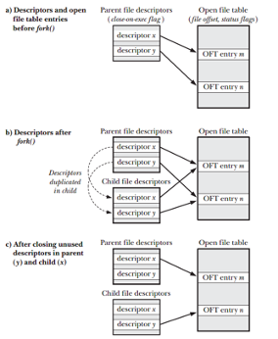

**IMPLEMENTATION**

We can use certain commands to view the process status, process control block (PCB), and the file descriptor table of a particular process.

1.Process Status

The operating system displays the following symbols to represent the states of a process.

* Running/ runnable – **R**
* Sleep (Interruptible) – **S**
* Uninterruptible sleep – **D**
* Stopped – **T**
* Zombie – **Z**

A process starts its life with R.

Write a program to create a child process. Now we will observe the process state of this process, tracing the following commands.

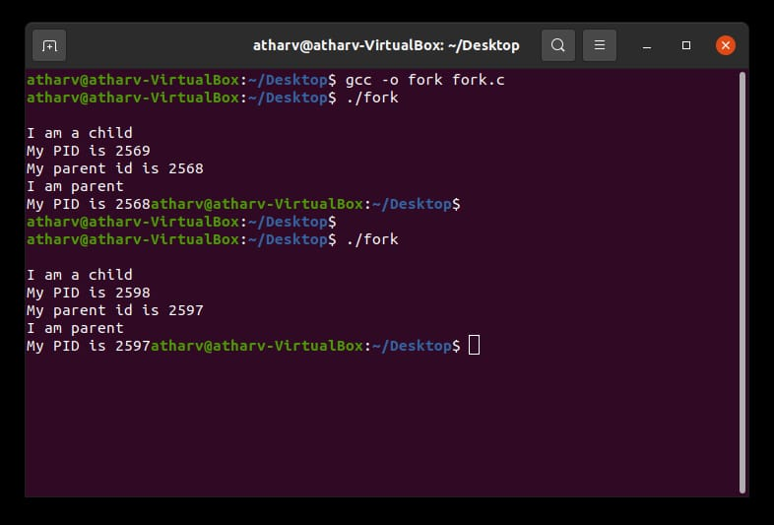

Follow the steps below to convert a file (program) to a process

1. ls
2. gcc -o fork fork.c
3. ./fork (becomes a process)

Now open another terminal and type ps -al command.

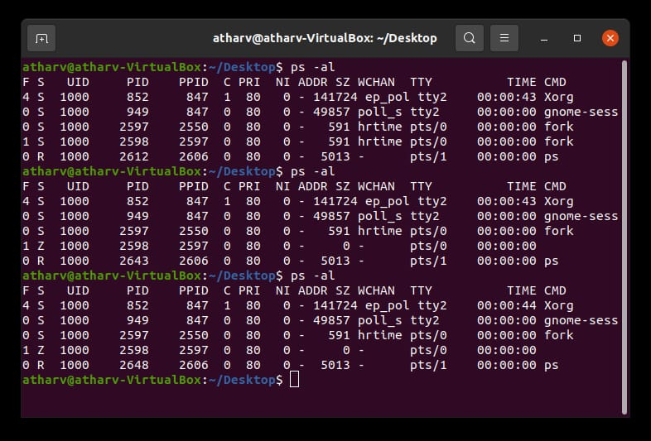

Child will complete its execution and try to return its exit state to parent. But parent won’t listen as it is sleeping. So, the child becomes a zombie. 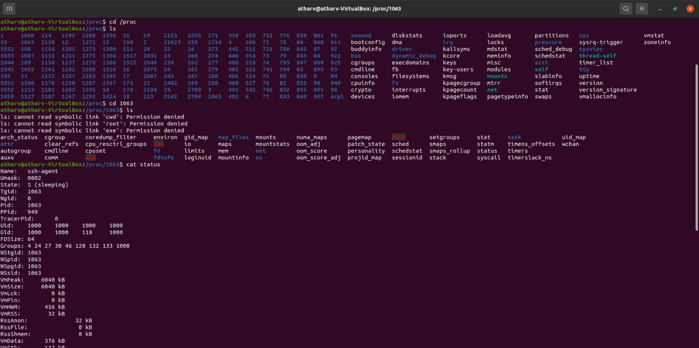

2.Process Control Block

1. cd /proc

2. ls

3. cd pid

4. ls

These commands will finally display the PCB of a process with that particular PID as mentioned above.

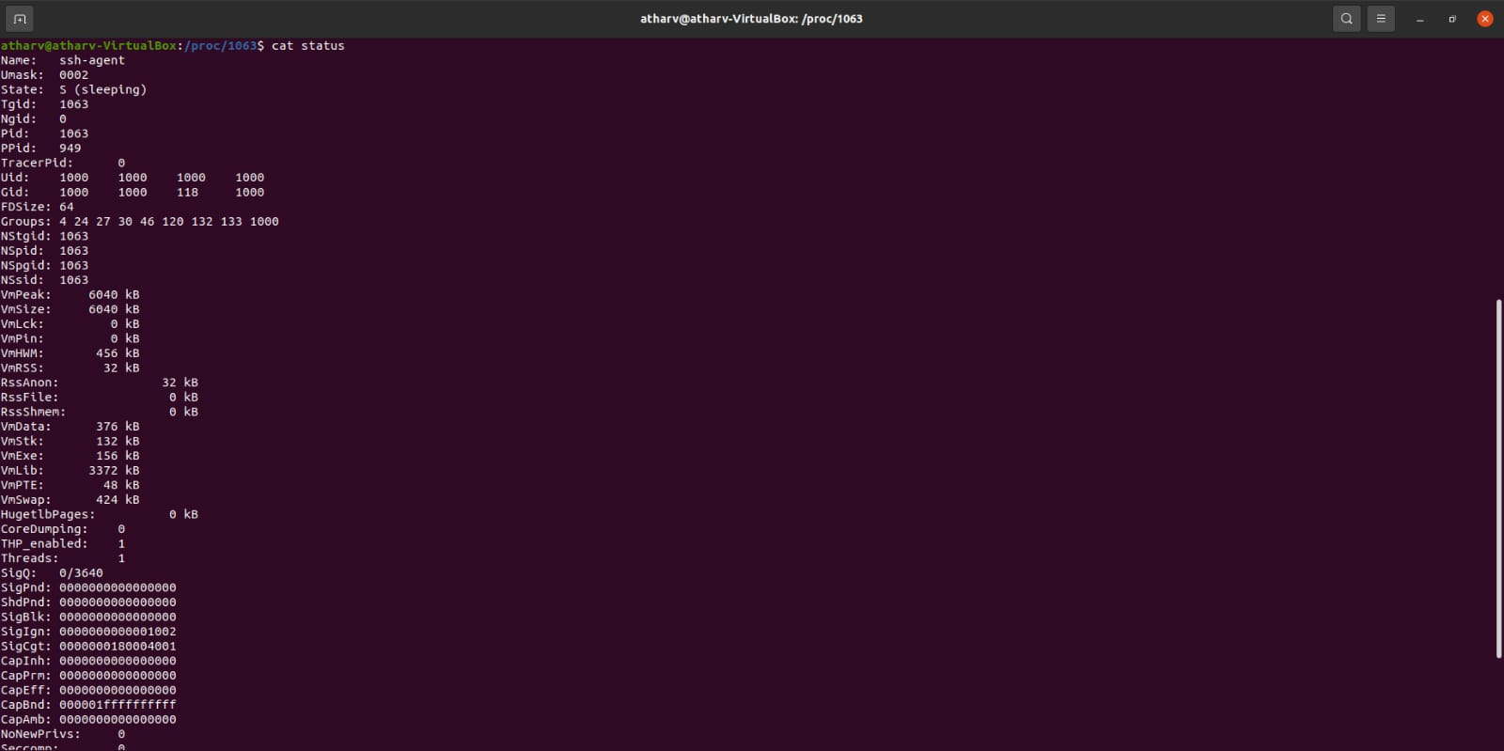

5.cat status

This will display some parameters like user id, pid and some details about context switching etc.

6. cd task

7. ls- It will display the pid of the current running process.

8. cd pid

9. ls

Now we will get complete backup of the PCB of that particular process.

10. cd net/- This will display the network statistics of the process.

These are some of the commands which we can use to get different types of information. We can even use some other commands to get the information of the file descriptor table.

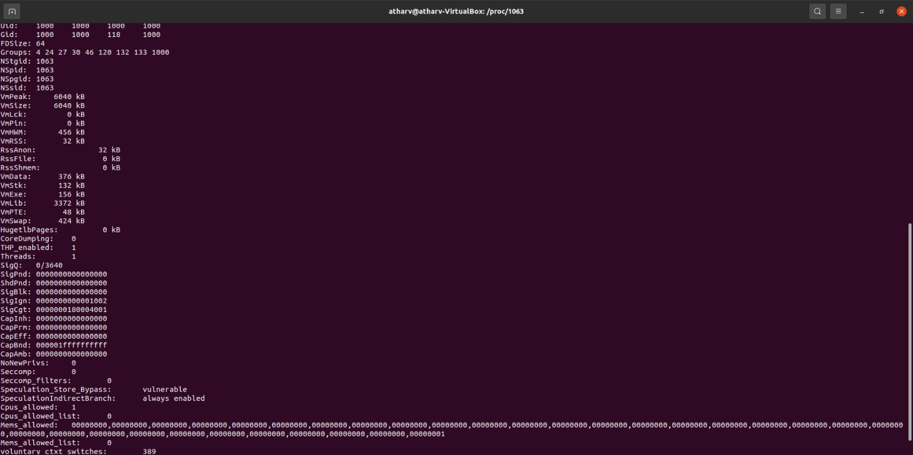

3.File Descriptor Table

The file descriptor is one of the fields within the process control block (PCB). It is a structure or an array which keeps track of all the resources that the process owns and it can operate.

The fd table holds pointers to resources. Here, the resources refer to files, terminal input, pipes, sockets, devices.

When the process uses resources, they will have an entry into the fd table.

In the fd table the first three indices are fixed for standard input (stdin), standard output (stdout), and standard error (stderr).

